Picking highest product in Amazon.com and Add to cart

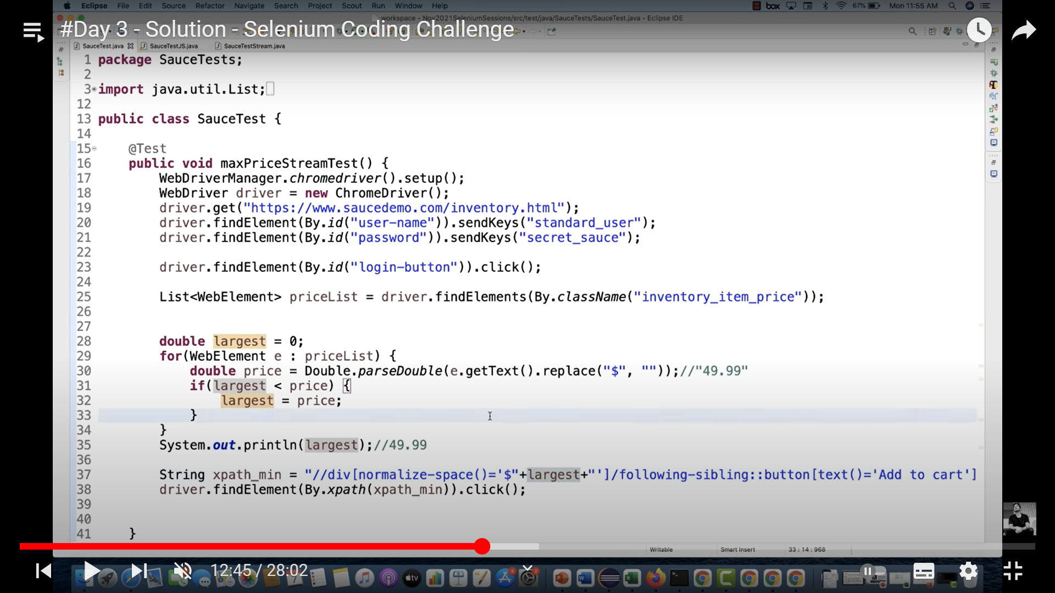

**Reverse string:**

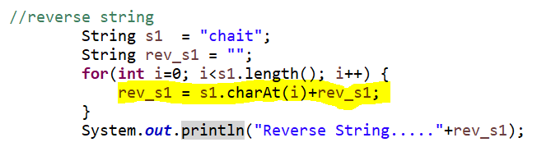

**Printing words in reverse order**

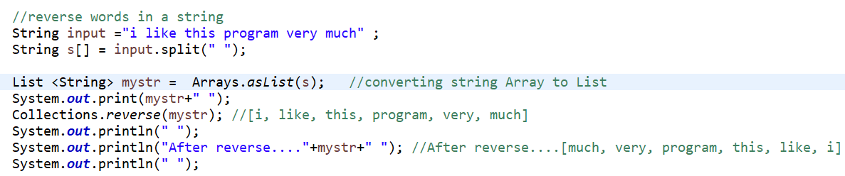

**Getting repeatable characters in a String**

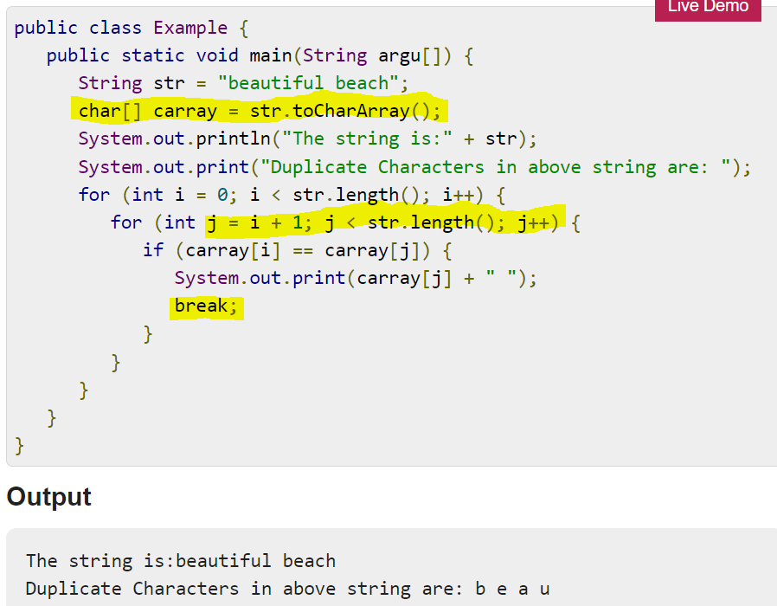

**Removing Dup letters in a sentence string:**

